Special Educational Needs and Disabilities(SEND) Information Report
St. Margaret’s Collier Street CoE Primary School



SEND Governor:
Catherine Jones

SENCO:
Emma Findlay

Contact No. 01892 730264
office@collier-street.sch.uk

Approved by: | Governors | Date: November 2025
Last reviewed on: | First edition  Please see website for previous Annual SEN Reports (https://collier-street.kent.sch.uk/school-information/special-educational-needs/useful-sen-documents/)
Next review due by: | November 2026

Contents
1. What types of SEND does the school provide for? 4
2. Which staff will support my child? 5
3. What should I do if I think my child has SEND? 7
4. What happens if the school identifies a need? 8
5. How will the school measure my child’s progress? 9
6. How will I be involved in decisions made about my child’s education? 10
7. How will my child be involved in decisions made about their education? 11
8. How will the school adapt its teaching for my child? 12
9. How will the school evaluate whether the support in place is helping my child? 144
10. How will the school ensure my child has appropriate resources? 14
11. How will the school make sure my child is included in activities alongside pupils who don’t have SEND? 15
12. How does the school make sure the admissions process is fair for pupils with SEN or a disability? 16
13. How does the school support pupils with disabilities? 16
14. How will the school support my child’s mental health and emotional and social development? 17
15. What support is in place for looked-after and previously looked-after children with SEN? 18
16.What support will be available for my child as they transition between classes or settings or in preparing for adulthood? 18
17. What support is available for me and my family? (Local Offer) 20
18. What should I do if I have a complaint about my child’s SEND support? 21
19. Supporting Documents…………………………………………………………………………………………………………….21
20. Glossary 22

Dear parents and carers,
The aim of this Information Report is to explain how we implement our SEND policy. In other words, we want to show you how SEND support works in our school.
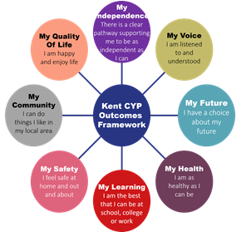
As educational professionals, we are all working towards the ultimate goal of growing independent young people as they prepare for adulthood. All provision and support we provide is working towards achieving the Kent Children and Young People (CYP) Outcomes Framework:

If you want to know more about our arrangements for SEND, read our SEND policy alongside this Information Report.
You can find our SEND policy on our website.
https://www.collier-street.kent.sch.uk/media/1973/sen-policy-nov-24.docx
Note: If there are any terms we’ve used in this information report that you’re unsure of, you can look them up in the Glossary at the end of the report.

1. What types of SEND does the school provide for?

Our school provides for pupils with the following needs (as outlined in the SEND Code of Practice 2015):

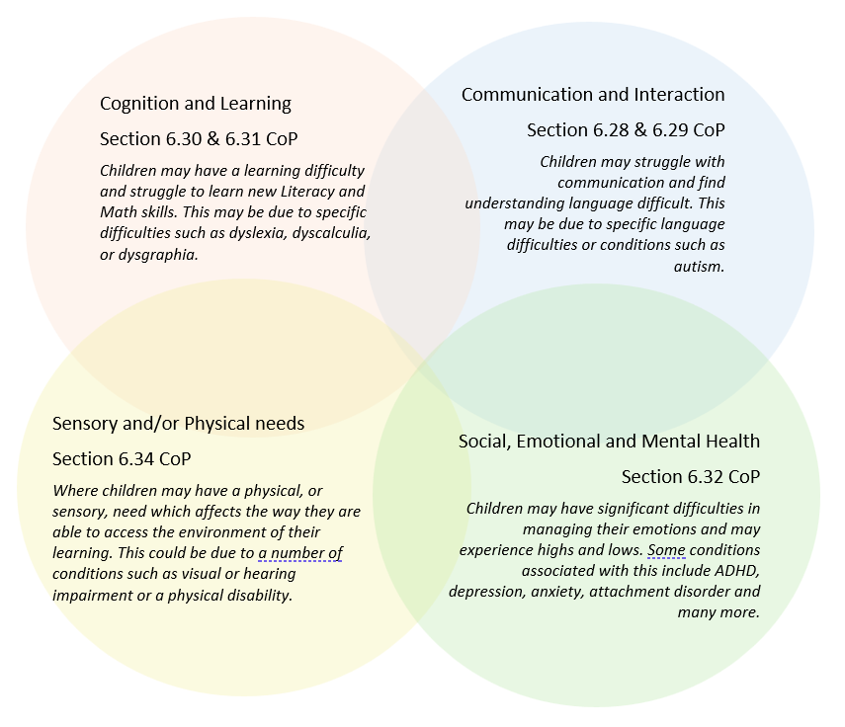

Often you will find that children’s needs overlap and are rarely confined to one area of need, which is why it is important to gain a wholistic overview of your child.
More information about the Areas of Need can be found in the Special educational needs and disability code of practice: 0 to 25 years (link below).
SEND_Code_of_Practice_January_2015.pdf (publishing.service.gov.uk)


2. Which staff will support my child, and what are their key responsibilities?

At St. Margaret’s Collier Street all staff are considered responsible for supporting the needs of pupils with SEND. Our staff are committed to regular, high-quality training to ensure that they have the knowledge and skills to better meet a wide range of pupil needs.
Below outlines key staff who will be supporting your child. Please note that this list is not exhaustive.
Our Special Educational Needs Co-ordinator, or SENCO
Our SENCO is Emma Findlay.
They have 14 experience in this role, have also worked as an Early Years SENCO, a Minority Ethnic Achievement Teacher for KCC and have been a qualified teacher for 25 years.
They achieved the National Award in Special Educational Needs Co-ordination in 2012 and qualified as a Reading Recovery Teacher in 2022. They have also attended further training in order to remain up to date with current practice, this includes (but is not limited to); SENCO Forums (Local and Countywide), This is Me, Autism Education Trust, Nurture UK.

Class/subject teachers
All of our teachers receive in-house SEN training, and are supported by the SENCO to meet the needs of pupils who have SEN.
Below is some of the external training that staff have received in the last year: Creating an Inclusive Classroom, Interactive Interventions Workshop, Nurture UK (including Boxall training)

Teaching assistants (TAs)
We have a team of 10 TAs, including 1 higher-level teaching assistant (HLTA) and 1 cover supervisor, who are trained to deliver SEN provision.
Our teaching assistants are trained to deliver interventions such as; 1st Class at Number, NELI, Little Wandle Catch Phonics Scheme (including Catch Up and Keep Up), Sensory Circuits, Speech Link and Language Link, Precision Teaching, Nurture Groups, Memory Magic, Talkabout and Theraplay.
Below is some of the external training that TAs have received in the last year: Level 5 Specialist Teaching Assistant Qualification (specializing in SEND), Creating an Inclusive Classroom and Using an Alphabet Arc.

External agencies
Sometimes we need extra help to offer our pupils the support that they need. Whenever necessary we will work with external support services to meet the needs of our pupils with SEND and to support their families. These may include:

- Child and adolescent mental health services (CAMHS)
- Child counsellors
- Early Help
- Education welfare officers
- Educational psychologists
- GPs or paediatricians
- NELFT practitioners
- NHS The Pod
- Occupational therapists
- Therapeutic practitioners
- Safeguarding services
- School nurses
- SEND Inclusion Advisor
- Specialist Teaching and Learning Service
- Speech and language therapists



- Voluntary sector organisations

3. What should I do if I think my child has SEND?

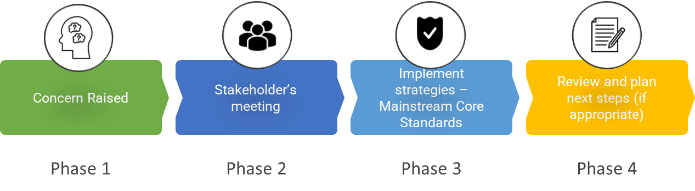

Phase 1 | If you think your child might have SEND, raise your concern with the school so that the SENCO is aware. It is best to initially speak to your child’s class teacher as they will know your child best, they can they speak to the SENCO.  Both the class teacher and the SENCO can be contacted through the school office (contact derails on front cover), or can be approached at the start or end of day.
Phase 2 | We will meet with you to discuss your concerns and try to get a better understanding of what your child’s strengths and difficulties are. Together we will decide what outcomes to seek for your child and agree on next steps. We will make a note of what’s been discussed and add this to your child’s record.
Phase 3 | We will implement the agreed strategies and monitor these over an agreed period of time. These are likely to be universal strategies set out in the mainstream core standards. A copy of this can be found here: https://www.kelsi.org.uk/__data/assets/pdf_file/0005/117257/Special-educational-needs-mainstream-core-standards-guide-for-parents.pdf. This will initiate the ‘Graduated Approach’ where support will be continually reviewed. See next page for more details.
Phase 4 | If we decide that your child needs SEND support, we will formally notify you and your child will be added to the school’s SEND register. They will receive additional support and this will be reviewed using the assess, plan, do, review model.

4. What happens if the school identifies a need?
The same process is followed if a concern is raised by the school.

All our class teachers are responsible for the monitoring of all pupils who have been identified as having SEND, and working closely with the SENCO to identify and meet pupils’ needs. They also review those who are not making the expected level of progress in their schoolwork or socially.This might include in Reading, Writing and Maths.
If the teacher notices that a pupil is having difficulties, they try to find out if the pupil has any gaps in their learning. If they can find a gap, the school will provide appropriate support, usually through Quality First Teaching, or through the deployment of strategies outlined in the Mainstream Core Standards. Pupils who don’t have SEND usually make progress quickly once the gap in their learning has been filled.
If the pupil is still finding it difficult to make the expected progress, the teacher will talk to the SENCO, and will contact you to discuss the possibility that your child has SEND, and the school will follow the graduated approach.

5. How will the school measure my child’s progress?

We will follow the ‘graduated approach’ to meeting your child’s SEND needs.
The graduated approach is a 4-part cycle of assess, plan, do, review.
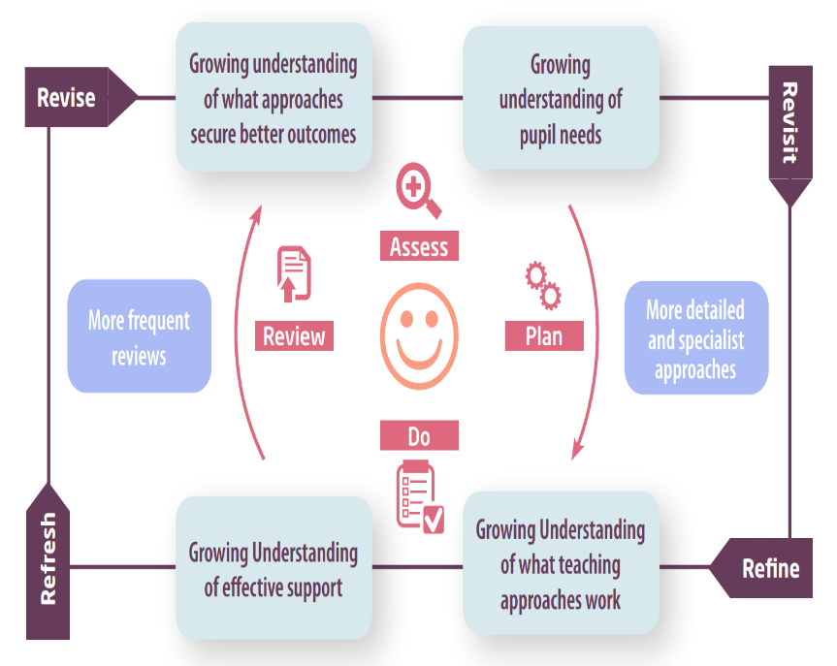

Assess | If your child is not making the expected level of progress, we will make an assessment to find out what strengths and difficulties your child has. We will ask for you and your child’s input, as well as getting help from external professionals where necessary.
Plan | In discussion with you and your child, we will decide what outcomes we are hoping to achieve. We will make a plan of the support we will offer your child to help them meet those outcomes. We will make a record of this and share it with all relevant school staff.
Do | We will put our plan into practice.  The class teacher, with the support of the SENCO, will be responsible for overseeing this plan on a daily basis, and making sure the support we put in place is having the impact we intended.
Review | We will assess how well the support we put in place helped the pupil to meet the outcomes we set. We will use our improved understanding of your child’s needs to improve the support we offer; this may mean the Plan, Assess, Do, Review cycle continues. Progress Review Meetings are a key part of this.

6. How will I be involved in decisions made about my child’s education?

All parents at St Margaret’s Collier Street are invited to discuss the progress of their children on two occasions a year and receive a written report once a year. In addition, we are happy to arrange meetings outside of these times.
A member of staff who knows your child well will meet you at least 3 times a year to:
- Set clear outcomes for your child’s progress
- Review progress towards those outcomes
- Discuss the support we will put in place to help your child make that progress
- Identify what we will do, what we will ask you to do, and what we will ask your child to do

The SENCO may also attend these meetings to provide extra support.
We know that you are the expert when it comes to your child’s needs and aspirations. So, we want to make sure you have a full understanding of how we are trying to meet your child’s needs, so that you can provide insight into what you think would work best for your child.
We also want to hear from you as much as possible so that we can build a better picture of how the SEND support we are providing is impacting your child outside of school.
If your child’s needs or aspirations change at any time, please let us know right away so we can keep our provision as relevant as possible.
If you have concerns that arise between these meetings, please contact your child’s class teacher or the SENCO (contact details on front cover).

7. How will my child be involved in decisions made about their education?

The level of involvement will depend on your child’s age and individual needs. We recognise that no two pupils are the same, so we will decide on a case-by-case basis, with your input.

We may seek your child’s views by asking them to:
- Attend meetings to discuss their progress and outcomes
- Prepare a presentation, written statement, video, drawing, etc.
- Discuss their views with a member of staff who can act as a representative during the meeting
- Complete a survey



8. How will the school adapt its teaching for my child?

At St. Margaret’s Collier Street, the quality of teaching is judged to be ‘Good’, in our latest OFSTED inspection. The report states that:
Leaders have made sure that pupils study a broad and balanced curriculum. They have high aspirations for pupils to achieve well…. Staff ensure that pupils with special educational needs and/or disabilities (SEND) receive the support they need to learn well.
Your child’s teacher is responsible and accountable for the progress and development of all the pupils in their class. High-quality teaching, adapted for individual pupils, is our first step in responding to your child’s needs. We will make sure that your child has access to a broad and balanced curriculum in every year they are at our school.
We will adapt our approaches to how we teach to suit the way the pupil works best. There is no 'one size fits all’ approach to adapting the curriculum, we work on a case-by case basis to make sure the adaptations we make are meaningful to your child and are guided by the Mainstream Core Standards in the first instance.
These adaptations may include:

- Adapting our approaches, for example, giving longer processing times, pre-teaching of key vocabulary, reading instructions aloud, etc.

- Adapting our resources and staffing

- Using recommended aids, such as laptops, coloured overlays, visual timetables, larger font, etc.

- Teaching assistants or support staff will support pupils appropriately depending on their presentation of need

- Scaffolding lesson materials

- We have also agreed a set of 5 key strategies which can support all learners, ‘5 a day for Collier Street’. These are a result of looking at the EEF ‘5 a Day’ and taking part in KCC training ’Creating an Inclusive Classroom’. These strategies are:

  - Modelling – worked examples, ‘I do, we do, you do’
  - Feedback – effective feedback, live marking
  - Retrieval Practice - regular recapping of key learning
  - Effective Questions
  - Chunking
- For further information about how we adapt our curriculum please see ‘Adapting The Curriculum’ here:
https://www.collier-street.kent.sch.uk/media/1595/adapting-the-curriculum.pdf

We may also provide the following interventions:
Communication & Interaction: NELI, Speech Link, Language Link, Socially Speaking, Talkabout
Cognition & Learning: Little Wandle Phonics (Keep Up & Catch Up), 1st Class at Number, Nessy Reading and Spelling, Precision Teaching, Memory Magic
Social, Emotional and Mental Health: Key person approach, check ins, Counselling, Nurture
Sensory and/or Physical: Movement breaks, Alternatives to Writing, Touch typing, BEAM, Clever Fingers, Handwriting (Write from the Start, Speed Up Handwriting)

These interventions are part of our contribution to Kent County Council’s local offer.

9. How will the school evaluate whether the support in place is helping my child?

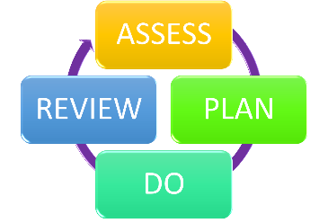
We will evaluate the effectiveness of provision for your child by:
- Reviewing their progress towards their goals each term
- Reviewing the impact of interventions after 10/12 weeks
- Listening to Pupil Voice
- Monitoring by the SENCO
- Using provision maps to measure progress
- Holding an annual review (if they have an education, health and care (EHC) plan)
Pupils with an EHCP will be invited to contribute to and attend an Annual Review Meeting, which, wherever possible will also include other agencies involved with the child.

10. How will the school ensure my child has appropriate resources?

Funding is in place to ensure that there is sufficient resources to support pupils requiring SEND support. The amount of support required for each pupil to make good progress will be different in each case. In a very few cases a very high level of resource is required. Currently there are changes occurring with the way that this support is funded, for more information please see the following document:
https://www.kelsi.org.uk/__data/assets/pdf_file/0009/215577/Support-for-Schools-Conversations-with-Parents-June-2025-Updated-180625.pdf
It may be that your child’s needs mean we need to provide additional resources such as:
- Additional resources to support their learning
- Adaptations to in class support
- Further training for our staff
- External specialist expertise
Where appropriate, we will consult with external agencies to get recommendations on what will best help your child access their learning and use our best endeavours to ensure these are supplied.

11. How will the school make sure my child is included in activities alongside pupils who don’t have SEND?


The expectation is that all schools providing an inclusive provision for all pupils. It may be necessary for some pupils to receive interventions in addition to a broad and balanced curriculum.
All of our extra-curricular activities and school visits are available to all our pupils, including our before and after-school clubs.
All pupils are encouraged to go on our school trips, including our residential trip to PGL.
All pupils are encouraged to take part in sports day, schools plays, church services and special workshops.
No pupil is ever excluded from taking part in these activities because of their SEN or disability and we will make whatever reasonable adjustments are needed to make sure that they can be included.


12. How does the school make sure the admissions process is fair for pupils with SEN or a disability?

For prospective pupils with SEN or a disability, including those with an EHCP, our admission arrangements will include meeting with our SENCO, Class Teacher and/or Headteacher prior to starting, to ensure that we have a plan to meet your child’s needs.
During this meeting, your child’s strengths and needs will be discussed, as well as what provision will be put in place to support their learning, physical health and well being.
Your child will be supported throughout this process, and parents will have regular opportunities to meet with the SENCO and/or class teacher as described earlier.
Please find more information about admissions here:
https://www.collier-street.kent.sch.uk/school-information/admissions/

13. How does the school support pupils with disabilities?


You are disabled under the Equality Act 2010 if you have a physical or mental impairment that has a ‘substantial’ and ‘long-term’ negative effect on your ability to do normal daily activities.
At St. Margaret’s Collier Street, all pupils, regardless of disability, are supported and welcome. All pupils are treated fairly, with dignity and respect.
Our Accessibility Plan can be found here:
https://www.collier-street.kent.sch.uk/media/1796/accessibility-plan-dec-23.pdf

14. How will the school support my child’s mental health and emotional and social development?
At our school we understand that it is important to enable all pupils to develop emotional resilience, social skills and independence. We provide support for pupils to progress in their emotional and social development in the following ways:
- Quality First Teaching for all pupils, in line with Mainstream Core Standards guidance on supporting pupils with Social, Emotional and Mental Health Needs.
- Pupils, including those with SEND, are encouraged to be part of the School Council.
- Pupils with SEND are also encouraged to be part of pastoral and nurture based clubs, including Gardening and Lego Club.
- We provide extra pastoral support for listening to the views of pupils with SEND by adopting a key person approach. This chosen adult is usually a TA in the class which your child is in.
- We run a Nurture Group for pupils who needs extra support with social or emotional development. We use Boxall Profiles to show the impact that this group makes with pupils back in the classroom.
- For children who require further support we can access this through the School Nursing Service or through our school child counsellor.
- We have a ‘zero tolerance’ approach to bullying. At our school we understand our responsibility to respond promptly and effectively to issues of bullying. Further information can be found in our Anti-Bullying Policy: https://www.collier-street.kent.sch.uk/media/1609/anti-bullying-policy-2022.pdf

15. What support is in place for looked-after and previously looked-after children with SEND?


Emma Findlay is our designated teacher for looked-after and previously looked after children. Part of this role is to ensure that all teachers understand how a looked-after or previously looked-after pupil’s circumstances and their SEND might interact, and what the implications are for teaching and learning.
Pupils who are looked-after or previously looked-after will be supported much in the same way as any other child who has SEND. However, looked-after pupils will also have a personal education plan (PEP). We will make sure that the PEP and any SEND support plans or EHC plans are consistent and complement one another.

16. What support will be available for my child as they transition between classes or settings or in preparing for adulthood?
At our school, we work closely with the educational settings used by the pupils before they transfer to us in order to seek the information that will make the transfer as smooth as possible.
Pre-school and Nurseries into EYFS
We endeavour to contact pre-schools and visit pupils in their pre-school setting where appropriate. Parents and pupils are introduced to the school routines and expectations through a coffee morning and taster days. For children with SEN, liaison with specialist teachers and staff at the pre-school, and where appropriate, additional transition meetings, support the transition process.
In Year Transitions
Where a pupil with SEND or any other vulnerability is transferring into our school, the SENCO or class teacher will contact the child’s school to discuss the pupil. This may include discussing the pupil’s likes and dislikes, their needs and successful strategies. This discussion will allow staff to determine whether or not any additional transition arrangements are required.
Between years
Being a small school, pupils at St. Margaret’s Collier Street have the advantage of being very familiar with all areas of the school and school staff, so this is very helpful at times of transition. Due to our mixed year group classes, children are often taught by the same class teacher(s) for two consecutive years, which can be helpful, but can also make transition to a new teacher more challenging when it arises.
Hence we have a number of strategies in place:
- All pupils are involved in a ‘class swap’ session, where they spend time in their new classroom with their new teaching staff.
- All pupils are discussed at transition meetings. These are held in Term 6 and allow staff, both teachers and teaching assistants, to share details about pupils and ask questions. Boxall Profiles are used to support this process
- Pupils who find transitions challenging are offered the following:
  - Additional opportunities to visit the new classroom and staff, either by arrangement (e.g. at story time) or by ‘running errands’.
  - An opportunity to write a social story with a trusted member of staff, that can then be shared at home over the summer holiday.
  - An opportunity to join Nurture Group sessions for Term 6 and the first couple of weeks of Term 1. The focus of these sessions is change and transitions, with activities such as writing postcards to their new class teacher, or making passports to share their strengths and interests.

Children in Year 5 with an EHCP
- Parents and children to begin looking at secondary provision
- Parents will be contacted by KCC to provide their choice for secondary school
- The secondary school will be named in Spring of the following year. Parents have the right to appeal the decision.
- IASK can provide further information and support.
- At the Annual Review in Year, if a secondary provision has been named, staff from there will be invited to the meeting.

Secondary School Transition
- Wherever possible, the SENCO of the secondary school will come into our school for a meeting with our SENCO. They will discuss the needs of all the pupils who are receiving SEND support and meet the pupils.
- All Year 6 pupils take part in the Maidstone school’s transition programme in Term 6. This includes activities such as practicing a secondary school timetable or learning how to get organized independently.
- We encourage pupils to attend taster days, summer schools and encourage links with Nurture Groups (where offered).
- Where pupils require further support with transition to secondary school we use interventions to support this (e.g. Hamish and Milo) and have also enabled additional visits to the school with our staff also attending for support.
- The Year 6 teacher will complete transition forms which are requested by the Secondary School, giving key information about the children. The SENCO will support with this as necessary, and may fill in additional SEND forms.

17. What support is available for me and my family?
If you have questions about SEND, or are struggling to cope, please get in touch to let us know. We want to support you, your child and your family.
To see what support is available to you locally, have a look at Kent County Council’s local offer. Kent County Council publishes information about the local offer on their website:
https://www.kent.gov.uk/education-and-children/special-educational-needs-and-disabilities

Parents without internet access should make an appointment with the SENCO for support to gain the information they require.

Our local special educational needs and disabilities information advice and support service is Information Advice and Support Kent (IASK). Information Advice and Support Kent (IASK) provides a free and confidential, information, advice and support service, for parents of a disabled child or child with special educational needs and to children and young people up to age 25 who have a special educational need or disability.
Trained staff can provide impartial legally based information and support on educational matters relating to special educational needs and disabilities, including health and social care. The aim is to empower parents, children and young people to fully participate in discussions and make informed choices and decisions, also to feel confident to express their views and wishes about education and future aspirations.
They can be contacted on:
HELPLINE: 03000 41 3000
E-mail:iask@kent.gov.uk
https://www.kent.gov.uk/iask

Links and contact details of more services and agencies can be found on our website:
https://www.collier-street.kent.sch.uk/school-information/special-educational-needs/additional-advice-for-all-parents-and-carers/

National charities that offer information and support to families of pupils with SEND are:
- IPSEA
- SEND family support
- NSPCC
- Family Action
- Special Needs Jungle

18. What should I do if I have a complaint about my child’s SEND support?
The normal arrangements for the treatment of complaints at St. Margaret’s are used for complaints about provision made for special educational needs. We encourage parents to discuss their concerns with their child’s class teacher, our SENCO and/or our Headteacher to resolve the issue before making the complaint formal to the Chair of the Governing Body.

If you are not satisfied with the school’s response, you can escalate the complaint. In some circumstances, this right also applies to the pupil themselves.
Our school’s complaints policy can be found here: https://www.collier-street.kent.sch.uk/media/1974/complaints-policy-2024.pdf

There are some circumstances, usually for children who have an Education, Health and Care Plan, where there is a statutory right for parents to appeal against a decision of the Local Authority. Complaints which fall within this category cannot be investigated by the school.
To see a full explanation of suitable avenues for complaint, see pages 246 and 247 of the SEND Code of Practice.
If you feel that our school discriminated against your child because of their SEND, you have the right to make a discrimination claim to the first-tier SEND tribunal. To find out how to make such a claim, you should visit: https://www.gov.uk/complain-about-school/disability-discrimination
You can make a claim about alleged discrimination regarding:
- Admission
- Exclusion
- Provision of education and associated services
- Making reasonable adjustments, including the provision of auxiliary aids and services
Before going to a SEND tribunal, you can go through processes called disagreement resolution or mediation, where you try to resolve your disagreement before it reaches the tribunal. For more information please contact IASK for further information.

19. Supporting documents

- Equality and Diversity Policy
- Safeguarding Policy
- Behaviour Policy
- Accessibility Plan
- Attendance Policy
- SEN policy
- SEN & Disabilities Code of Practice 2015
- Mainstream Core Standards

20. Glossary
- Access arrangements –special arrangements to allow pupils with SEND to access assessments or exams
- Annual review –an annual meeting to review the provision in a pupil’s EHC plan
- Area of need –the 4 areas of need describe different types of needs a pupil with SEND can have. The 4 areas are communication and interaction; cognition and learning; physical and/or sensory; and social, emotional and mental health needs.
- CAMHS –child and adolescent mental health services
- Differentiation – when teachers adapt how they teach in response to a pupil’s needs
- EHC needs assessment –the needs assessment is the first step on the way to securing an EHC plan. The local authority will do an assessment to decide whether a child needs an EHC plan.
- EHC plan –an education, health and care plan is a legally-binding document that sets out a child’s needs and the provision that will be put in place to meet their needs.
- First-tier tribunal/SEND tribunal –a court where you can appeal against the local authority’s decisions about EHC needs assessments or plans and against discrimination by a school or local authority due to SEND
- Graduated approach–an approach to providing SEND support in which the school provides support in successive cycles of assessing the pupil’s needs, planning the provision, implementing the plan, and reviewing the impact of the action on the pupil
- Intervention –a short-term, targeted approach to teaching a pupil with a specific outcome in mind
- Local offer –information provided by the local authority which explains what services and support are on offer for pupils with SEND in the local area
- Outcome –target for improvement for pupils with SEND. These targets don't necessarily have to be related to academic attainment
- Reasonable adjustments –changes that the school must make to remove or reduce any disadvantages caused by a child’s disability
- SENCO –the special educational needs co-ordinator
- SEN –special educational needs
- SEND–special educational needs and disabilities
- SEND Code of Practice–the statutory guidance that schools must follow to support pupils with SEND
- SEND information report–a report that schools must publish on their website, that explains how the school supports pupils with SEND
- SEND support –special educational provision which meets the needs of pupils with SEND
- Transition–when a pupil moves between years, phases, schools or institutions or life stages

